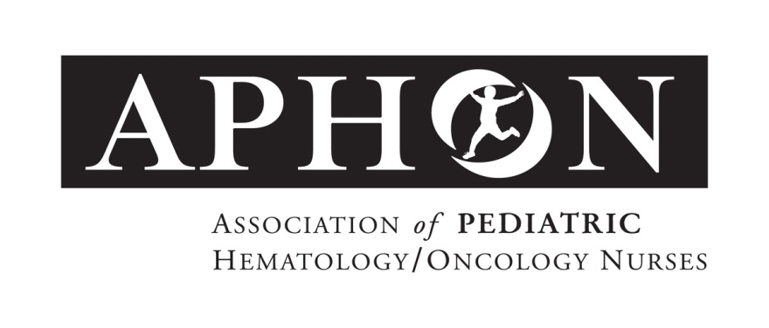

For Immediate Release Contact: Stephanie Sayen
ssayen@aphon.org
847.375.4864

APHON Announces 40 Years of Advancement

Chicago (Feb. 10, 2016): Join APHON in officially marking 40 years of advancement and leadership in pediatric hematology/oncology nursing and patient care. The association has planned celebratory events throughout the year, some of which will take place at the 2016 APHON Annual Conference and Exhibit, September 29-October 1, in Indianapolis, IN.

APHON originated as an impromptu meeting in 1973 of four pediatric oncology nurses who felt the need to share practice problems and successes, knowledge and mutual support. In just three short years, the Association of Pediatric Oncology Nurses was formed. This group was officially incorporated in 1976.

In 2006, the organization acknowledged that most members care for hematology patients as well as oncology patients and voted to add Hematology to the APHON (Association of Pediatric Hematology/Oncology Nurses) name, thereby supporting all members of this specialized community of nurses.

APHON has grown exponentially and continues to be an asset for pediatric hematology/oncology nurses everywhere. APHON produces award winning publications for both nursing education as well as patient family education. The Pediatric Chemotherapy and Biotherapy Program introduced in 2004 for example, continues to provide nurses with the knowledge needed to safely care for children and adolescents receiving chemotherapy or biotherapy. This highly successful program is now comprised of nearly 18,000 providers and 550 instructors.

The fields of pediatric hematology/oncology, along with APHON have made immense advancements in its 40 years. APHON continues to innovate and provide nurses with relevant and cutting edge educational resources, live conferences, networking opportunities and best practices. APHON is proud to be celebrating 40 years of leadership and the very important role it has played in providing care for children, adolescents and young adults with cancer and blood disorders, and their families.

About APHON

APHON is the professional organization for pediatric hematology/oncology nurses and other pediatric hematology/oncology healthcare professionals. Its members are dedicated to promoting optimal nursing care for children, adolescents and young adults with cancer and blood disorders, and their families. APHON provides the leadership and expertise to pediatric hematology/oncology nurses by defining and promoting the highest standards of practice and care to the pediatric, adolescent and young adult communities. For more information about APHON, visit www.aphon.org.

###

