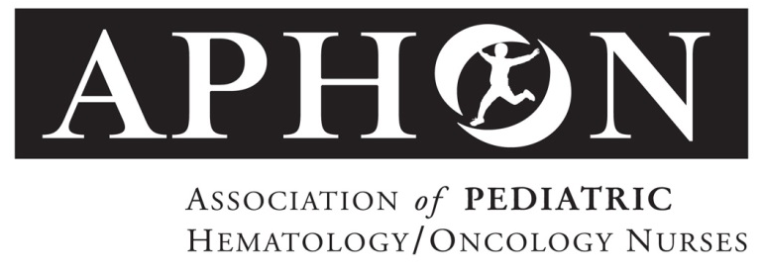

For Immediate Release Contact: Stephanie Sayen
ssayen@aphon.org
847.375.4864

APHON Supports Full Practice Authority for APRNs in the VA

Chicago (July 25, 2016): APHON submitted comments to the Department of Veterans Affairs (VA) supporting regulations to allow Advanced Practice Registered Nurses (APRNs) to practice to the full extent of their education, training, and certification. The pediatric hematology/oncology APRN’s scope of practice embraces the entire lifespan from infants to adults and the full trajectory from diagnosis to long-term survivorship/health surveillance of cancer or chronic blood disorders.

“Childhood cancer survivors, and individuals with serious chronic blood disorders need lifelong health monitoring and care, which can be best addressed by removing scope of practice barriers and allowing APRNs to practice to the full extent of their education and training,” said APHON President, Kathleen Ruccione, PhD MPH RN FAAN®. “Granting APRNs full practice authority within the VA would provide a strong precedent for how healthcare as a whole is delivered in all settings.”

APHON promotes the development of a sustainable pediatric hematology/oncology nursing workforce, capable of meeting increasingly complex healthcare demands through education, research, and best practices. To that end, APHON supports the recommendation to remove scope-of-practice barriers impacting APRNs.

About APHON

APHON is the professional organization for pediatric hematology/oncology nurses and other pediatric hematology/oncology healthcare professionals. Its members are dedicated to promoting optimal nursing care for children, adolescents and young adults with cancer and blood disorders, and their families. APHON provides the leadership and expertise to pediatric hematology/oncology nurses by defining and promoting the highest standards of practice and care to the pediatric, adolescent and young adult communities. For more information about APHON, visit www.aphon.org.

###

