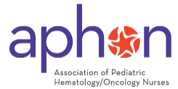
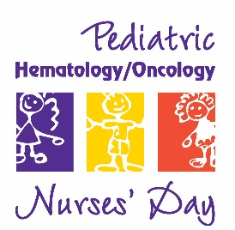

Pediatric Hematology/Oncology Nurses Day September 8

Chicago, IL: The Association of Pediatric Hematology/Oncology Nurses (APHON) announces the establishment of Pediatric Hematology/Oncology Nurses Day September 8, 2010, nationwide. Always striving to learn best practices, contribute to and advance the field of knowledge, and share the vision of a cancer and blood disorder free future, pediatric hematology nurses are now being recognized on a national scale for their role in the treatment of cancer and blood disorders.
Each day, Pediatric Hematology/Oncology Nurses care for many of our most precious patients: children, adolescents, and young adults with cancer and blood disorders. These special nurses are dedicated to providing the highest standard of care to their patients and families. Often, that care extends beyond their physical health, to include emotional support and long term following up treatment as they mature into adults. “September is Childhood Cancer Awareness month, and what a fine complement to that month, should we establish a day recognizing those nurses who care for the day to day needs of children with cancer and blood disorders, guiding families through the most difficult circumstances anyone can experience, “ declares Deb Echtenkamp, APHON past president.
APHON is the professional organization for pediatric hematology/oncology nurses and other pediatric hematology/oncology healthcare professionals. Its members are dedicated to promoting optimal nursing care for children, adolescents, and young adults with cancer and blood disorders, and their families. APHON provides the leadership and expertise to pediatric hematology/oncology nurses by defining and promoting the highest standards of practice and care to the pediatric, adolescent, and young adult communities.
###

