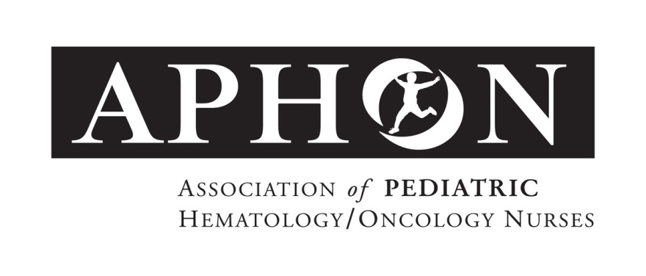

For Immediate Release Contact: Stephanie Sayen
ssayen@aphon.org
847.375.4864

APHON Receives Top ASAE Honors for its
Pediatric Chemotherapy/Biotherapy Provider Program

Chicago (August 1, 2016): APHON has earned both a 2016 ASAE Power of A Gold and Silver Award for its Pediatric Chemotherapy/Biotherapy Provider Program. The objectives of the APHON Chemotherapy and Biotherapy Provider Program are to establish education and practice standards for the administration of chemotherapy and biotherapy to children and adolescents and to promote consistent practices in the administration of chemotherapy and biotherapy to pediatric and adolescent oncology patients.

“Congratulations to APHON and its partners for their hard work and for helping to make the world a better place,” said Sharon J. Swan, chair of the Power of A Awards Judging Committee. “Their initiative exemplifies how associations are a positive force in our everyday lives- not just to the profession of industry they represent, but to society at large.”

APHON President, Kathleen Ruccione, PhD MPH RN FAAN® shares, “We estimate that nurses trained by this program have given over two million episodes of chemotherapy and/or biotherapy to children and adolescents/young adults in the last five years alone. Every one of these episodes was a safer experience because of the program. We are so proud of the outstanding APHON members and staff who developed and carry out the program recognized by this award.”

The Power of A Awards reward outstanding accomplishments of associations and industry professionals for their efforts to enrich lives, create a competitive workforce, prepare society for the future, drive innovation and make a better world.

About APHON

APHON is the professional organization for pediatric hematology/oncology nurses and other pediatric hematology/oncology healthcare professionals. Its members are dedicated to promoting optimal nursing care for children, adolescents and young adults with cancer and blood disorders, and their families. APHON provides the leadership and expertise to pediatric hematology/oncology nurses by defining and promoting the highest standards of practice and care to the pediatric, adolescent and young adult communities. For more information about APHON, visit www.aphon.org.

###

